SQL Project - Financial Data Analysis (Online Bank)
Student Name: James Canning
1. Introduction
This project involves creating a relational database for an online banking system. The database is designed to store customer details, account information, transactions, and loan records. The SQL scripts provided demonstrate the creation of tables, insertion of data, and execution of queries to retrieve specific information as per project requirements.

2. Entity Relationship Diagram (ERD) 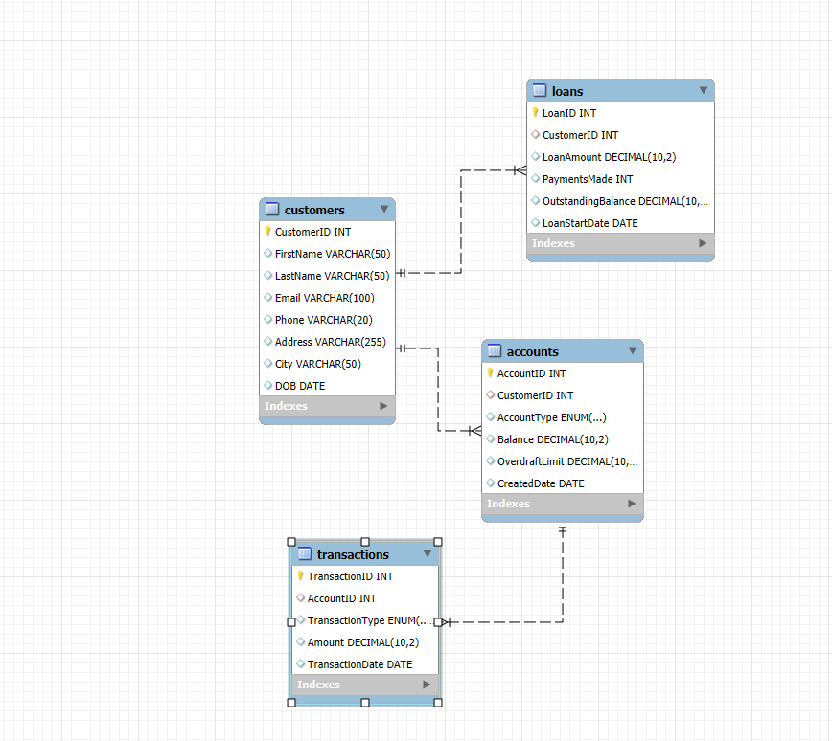

3. Database Schema Design
Tables and Fields
Customers Table
- CustomerID (Primary Key)
- FirstName
- LastName
- Email
- Phone
- Address
- City
- DOB
Accounts Table
- AccountID (Primary Key)
- CustomerID (Foreign Key → Customers)
- AccountType (Savings, Checking, Loan)
- Balance
- OverdraftLimit
- CreatedDate
Transactions Table
- TransactionID (Primary Key)
- AccountID (Foreign Key → Accounts)
- TransactionType (Deposit, Withdrawal, Transfer, Payment)
- Amount
- TransactionDate
Loans Table
- LoanID (Primary Key)
- CustomerID (Foreign Key → Customers)
- LoanAmount
- PaymentsMade
- OutstandingBalance
- LoanStartDate

4. SQL Code for Database Creation and Data insertion
CREATE DATABASE OnlineBank;
USE OnlineBank;

-- Table creation scripts

5. SQL Queries and Results
Query 1: Show details of customers whose surname starts with ‘J’
SELECT * FROM Customers WHERE LastName LIKE 'J%';
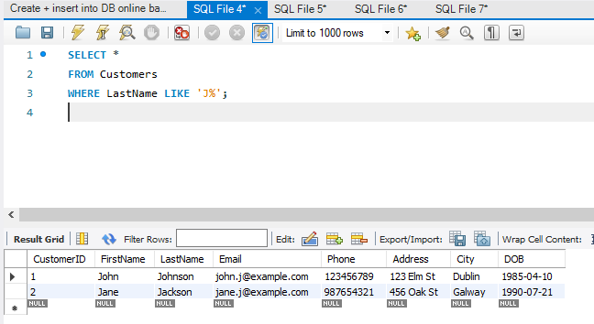
Query 2: Find customers with Savings > 5000, Overdrafts > 1000, and Loans with >3 payments
SELECT C.* FROM Customers C
JOIN Accounts A ON C.CustomerID = A.CustomerID
JOIN Loans L ON C.CustomerID = L.CustomerID
WHERE A.AccountType = 'Savings' AND A.Balance > 5000
AND A.OverdraftLimit > 1000 AND L.PaymentsMade > 3;
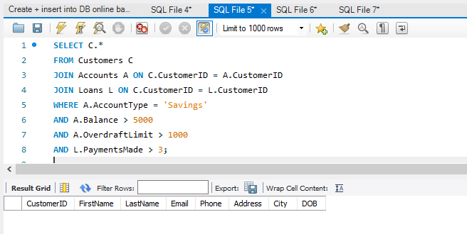
Query 3: Display customers who have NOT made a lodgment into savings in the last 3 months
SELECT C.* FROM Customers C
JOIN Accounts A ON C.CustomerID = A.CustomerID
LEFT JOIN Transactions T ON A.AccountID = T.AccountID
AND T.TransactionType = 'Deposit'
AND T.TransactionDate >= DATE_SUB(CURDATE(), INTERVAL 3 MONTH)
WHERE A.AccountType = 'Savings' AND T.TransactionID IS NULL;
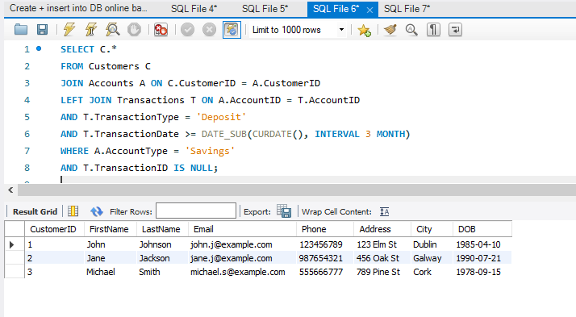
Query 4: Update all overdrafts and loans to ‘0.00’ for a specific customer
UPDATE Accounts SET OverdraftLimit = 0.00 WHERE CustomerID = 1;
UPDATE Loans SET OutstandingBalance = 0.00 WHERE CustomerID = 1;
